[](https://www.corso-vollenhove.nl/)[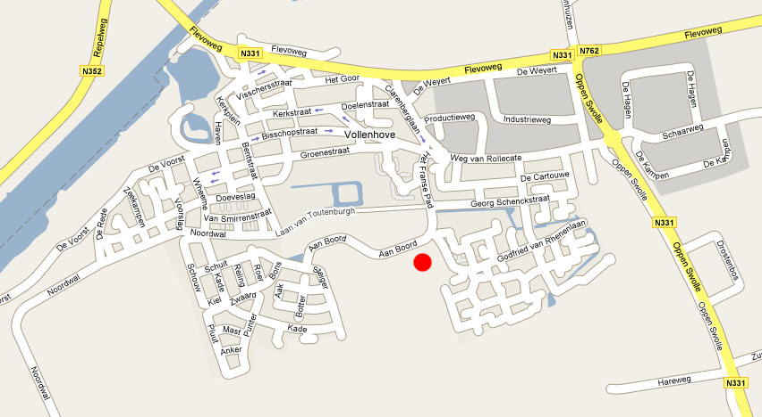](http://www.google.nl/url?sa=i&rct=j&q=&esrc=s&source=images&cd=&cad=rja&uact=8&ved=2ahUKEwjGwbLyhtHbAhXSblAKHSQEDBMQjRx6BAgBEAU&url=http://www.sv-veno.nl/2.5.9/index.php/contact&psig=AOvVaw1TJfwjlCFRhqpFaLidWYvy&ust=1528993463346597)