[](https://www.corso-vollenhove.nl/) Groep 1 en 2 DAHLIA MEMORIE (werkblad 1 van 2)

[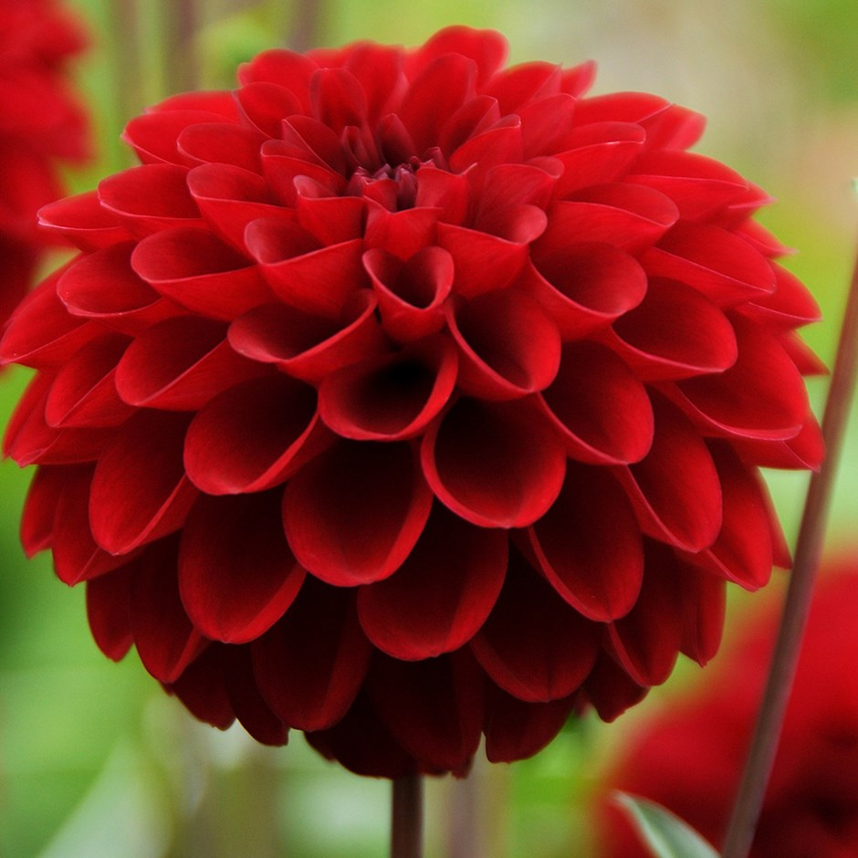](https://www.google.nl/url?sa=i&rct=j&q=&esrc=s&source=images&cd=&cad=rja&uact=8&ved=2ahUKEwj-3cjR2-_cAhVMLVAKHUHJAyQQjRx6BAgBEAU&url=https://www.crocus.co.uk/plants/_/dahlia-red-fox-pbr/classid.2000025529/&psig=AOvVaw1SIrMt6wCanT87tiji1UHz&ust=1534444356497794)

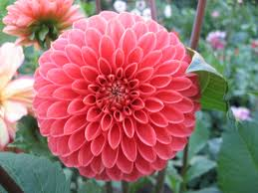



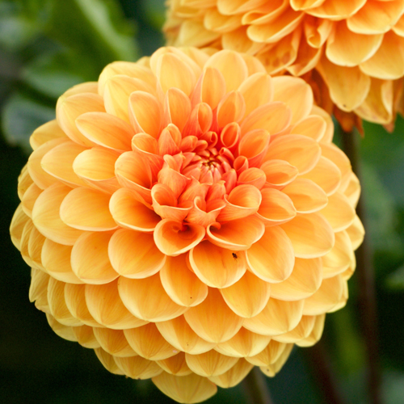

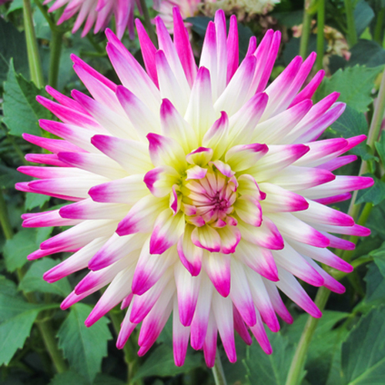





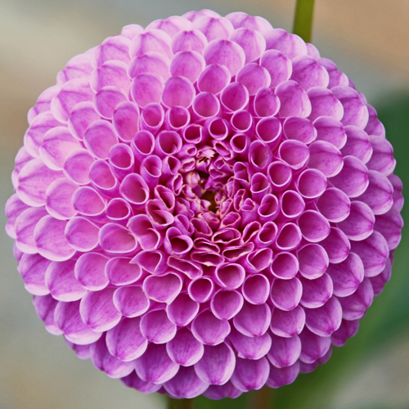



[](https://www.google.nl/url?sa=i&rct=j&q=&esrc=s&source=images&cd=&cad=rja&uact=8&ved=2ahUKEwj-3cjR2-_cAhVMLVAKHUHJAyQQjRx6BAgBEAU&url=https://www.crocus.co.uk/plants/_/dahlia-red-fox-pbr/classid.2000025529/&psig=AOvVaw1SIrMt6wCanT87tiji1UHz&ust=1534444356497794)

[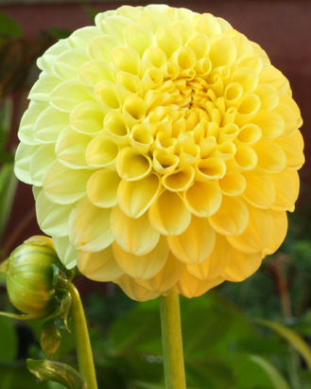](https://www.google.nl/url?sa=i&rct=j&q=&esrc=s&source=images&cd=&cad=rja&uact=8&ved=2ahUKEwienL3j2-_cAhXOJVAKHRdYDhwQjRx6BAgBEAU&url=https://www.bloembollenkopen.nl/dahlia/dahlia-pompon-geel.html&psig=AOvVaw1SIrMt6wCanT87tiji1UHz&ust=1534444356497794)

[](https://www.google.nl/url?sa=i&rct=j&q=&esrc=s&source=images&cd=&cad=rja&uact=8&ved=2ahUKEwienL3j2-_cAhXOJVAKHRdYDhwQjRx6BAgBEAU&url=https://www.bloembollenkopen.nl/dahlia/dahlia-pompon-geel.html&psig=AOvVaw1SIrMt6wCanT87tiji1UHz&ust=1534444356497794)

[](https://www.corso-vollenhove.nl/) Groep 1 en 2 DAHLIA MEMORIE (werkblad 2 van 2)

[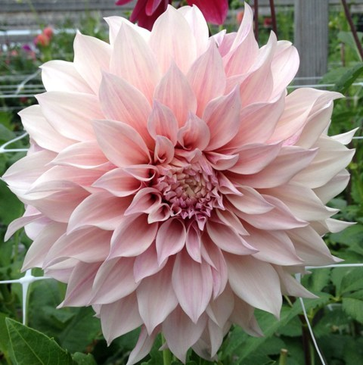](http://www.alphadahlias.com/cafe-au-lait-popular-blush-colored-dahlia)

[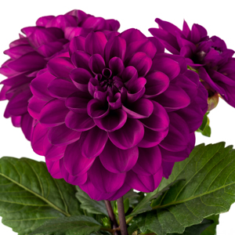](https://www.beekenkamp.nl/plants/dahlia/)

[](https://www.beekenkamp.nl/plants/dahlia/)

[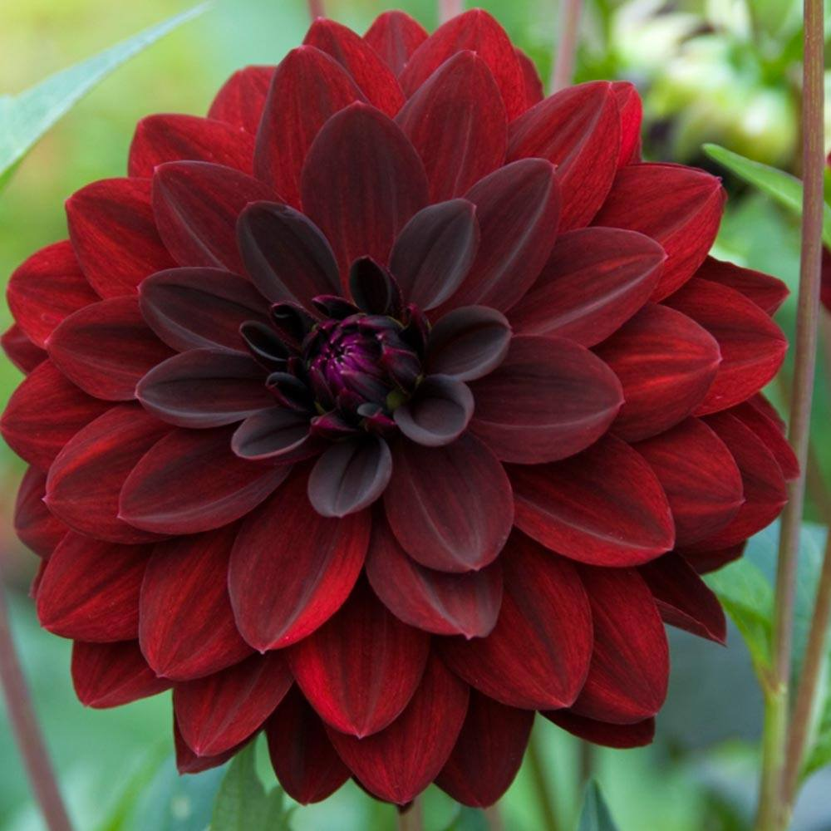](https://www.google.nl/url?sa=i&rct=j&q=&esrc=s&source=images&cd=&cad=rja&uact=8&ved=2ahUKEwjY0Z7a4O_cAhUFZlAKHaYbDSkQjRx6BAgBEAU&url=https://www.jparkers.co.uk/3-dahlia-arabian-night-1010701&psig=AOvVaw0fws8fghRKXRCQyEbZ535x&ust=1534446346216028)

[](https://www.google.nl/url?sa=i&rct=j&q=&esrc=s&source=images&cd=&cad=rja&uact=8&ved=2ahUKEwjY0Z7a4O_cAhUFZlAKHaYbDSkQjRx6BAgBEAU&url=https%3A%2F%2Fwww.jparkers.co.uk%2F3-dahlia-arabian-night-1010701&psig=AOvVaw0fws8fghRKXRCQyEbZ535x&ust=1534446346216028)

[](http://www.alphadahlias.com/cafe-au-lait-popular-blush-colored-dahlia)

[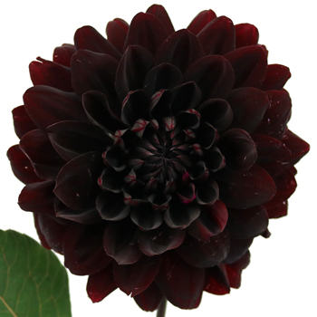](https://www.google.nl/url?sa=i&rct=j&q=&esrc=s&source=images&cd=&cad=rja&uact=8&ved=2ahUKEwicjaLg3-_cAhWSalAKHZkzCaQQjRx6BAgBEAU&url=https://www.fiftyflowers.com/product/dahlia-burgundy-black-flower.htm&psig=AOvVaw12HGUEjiBcCTzixW9yaAKb&ust=1534446209657632)

[](https://www.google.nl/url?sa=i&rct=j&q=&esrc=s&source=images&cd=&cad=rja&uact=8&ved=2ahUKEwicjaLg3-_cAhWSalAKHZkzCaQQjRx6BAgBEAU&url=https%3A%2F%2Fwww.fiftyflowers.com%2Fproduct%2Fdahlia-burgundy-black-flower.htm&psig=AOvVaw12HGUEjiBcCTzixW9yaAKb&ust=1534446209657632)

[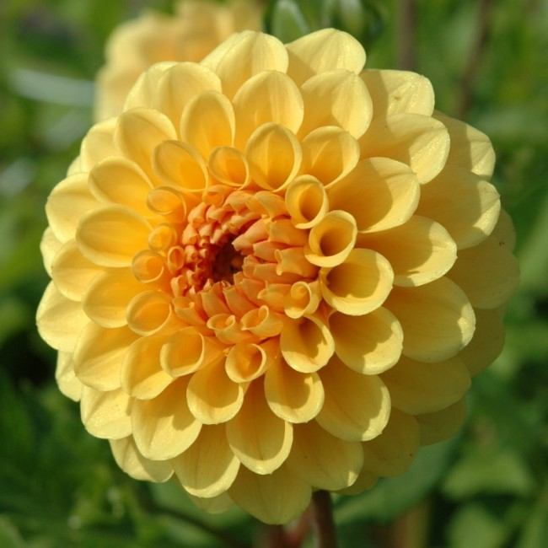](https://www.google.nl/url?sa=i&rct=j&q=&esrc=s&source=images&cd=&cad=rja&uact=8&ved=2ahUKEwi2tOHN3e_cAhVJJVAKHVFnDxkQjRx6BAgBEAU&url=https://www.queenflowerbulbs.nl/golden-scepter/&psig=AOvVaw0tvb5Il2XYJQFjwRMfN8iS&ust=1534445634183073)

[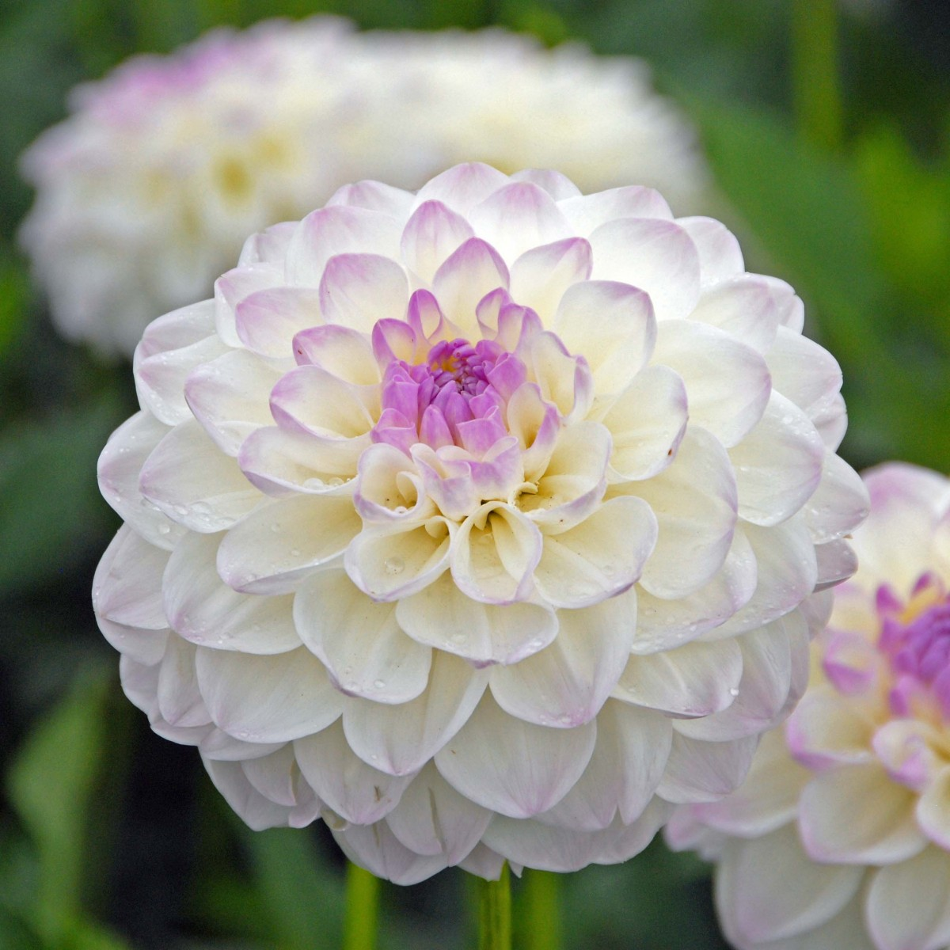](https://www.google.nl/url?sa=i&rct=j&q=&esrc=s&source=images&cd=&cad=rja&uact=8&ved=2ahUKEwiem5Lj3O_cAhVLZlAKHT8sDSQQjRx6BAgBEAU&url=https://www.fluwel.nl/dahlias/alle-dahlias/dahlia-eveline-1042.html&psig=AOvVaw1SIrMt6wCanT87tiji1UHz&ust=1534444356497794)

[](https://www.google.nl/url?sa=i&rct=j&q=&esrc=s&source=images&cd=&cad=rja&uact=8&ved=2ahUKEwi2tOHN3e_cAhVJJVAKHVFnDxkQjRx6BAgBEAU&url=https://www.queenflowerbulbs.nl/golden-scepter/&psig=AOvVaw0tvb5Il2XYJQFjwRMfN8iS&ust=1534445634183073)

[](https://www.google.nl/url?sa=i&rct=j&q=&esrc=s&source=images&cd=&cad=rja&uact=8&ved=2ahUKEwiem5Lj3O_cAhVLZlAKHT8sDSQQjRx6BAgBEAU&url=https%3A%2F%2Fwww.fluwel.nl%2Fdahlias%2Falle-dahlias%2Fdahlia-eveline-1042.html&psig=AOvVaw1SIrMt6wCanT87tiji1UHz&ust=1534444356497794)