[](https://www.corso-vollenhove.nl/)

GROEP 3 EN 4

Voorbeelden

Playmais

 [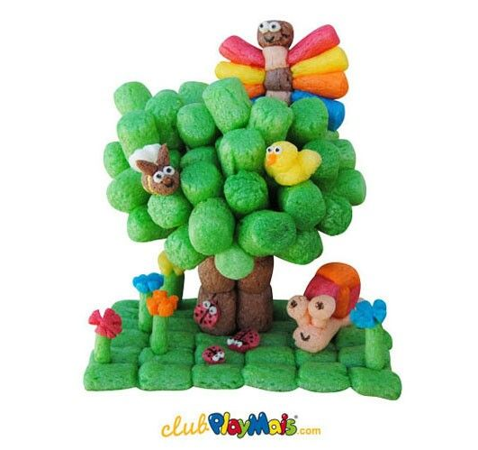](https://www.pinterest.com/juliarauschkolb/playmais/) 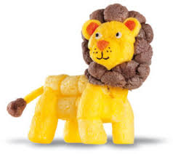[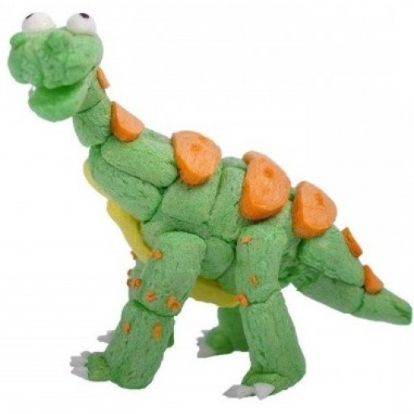](http://www.google.nl/url?sa=i&rct=j&q=&esrc=s&source=images&cd=&cad=rja&uact=8&ved=2ahUKEwj1t8aSgPDcAhVFKFAKHSXZAFYQjRx6BAgBEAU&url=http://www.engeltjesendraken.nl/speelgoed-merken/playmais&psig=AOvVaw1CQ8w0yEwqFNgphBoZ2n-M&ust=1534453718886789)[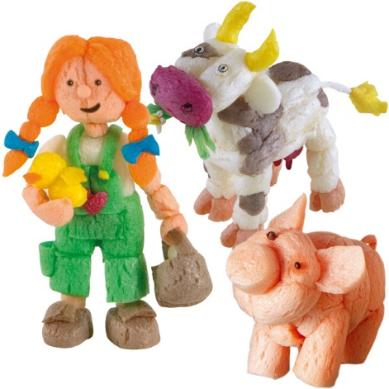](https://www.eurekakids.es/juguete/playmais/worls-farm)[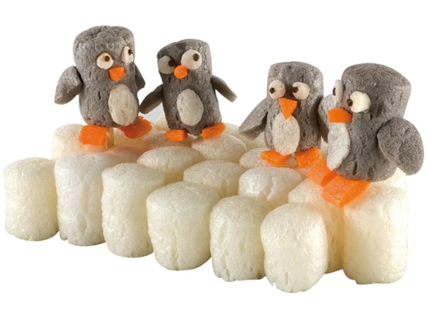](https://www.de-neef.be/documents/catalog/4153.xml?lang=nl)

[](https://www.google.nl/imgres?imgurl=https://i.pinimg.com/originals/6f/35/e9/6f35e912f2cef71acddec894b498c921.jpg&imgrefurl=https://www.pinterest.com.au/pin/810014682951228668/&docid=Ae0epJP9WGfV0M&tbnid=1cpt7Log3_nc_M:&vet=10ahUKEwj-1-fX--_cAhUFZlAKHYIKCoAQMwheKCAwIA..i&w=385&h=500&itg=1&bih=695&biw=1477&q=playmais%20voorbeelden&ved=0ahUKEwj-1-fX--_cAhUFZlAKHYIKCoAQMwheKCAwIA&iact=mrc&uact=8) [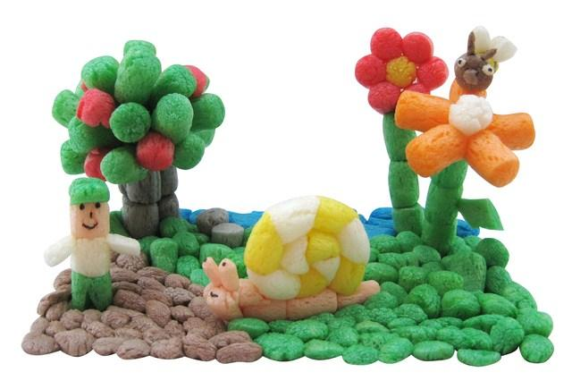](http://www.google.nl/url?sa=i&rct=j&q=&esrc=s&source=images&cd=&cad=rja&uact=8&ved=2ahUKEwjG2pfzgfDcAhVJZlAKHZ1QBCwQjRx6BAgBEAU&url=http://www.ladidacteca.es/view/980/playmais-libro-mis-primeras-creaciones-&psig=AOvVaw1CQ8w0yEwqFNgphBoZ2n-M&ust=1534453718886789)

Meer voorbeelden zijn te vinden op internet!