[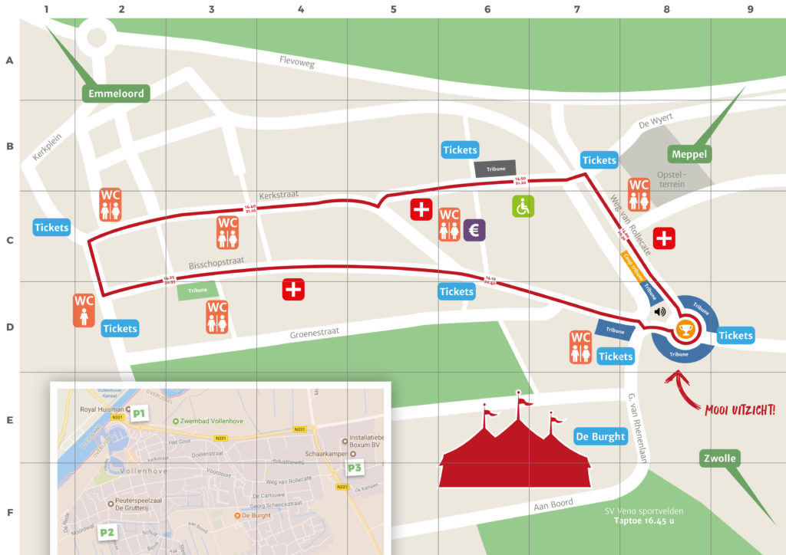](https://www.corso-vollenhove.nl/wordpress/wp-content/uploads/2017/08/CV_Plattegrond2017_Raster.jpg)